Exercise 3 Unit 1

* We create a new virtual machine Ubuntu 64-bit

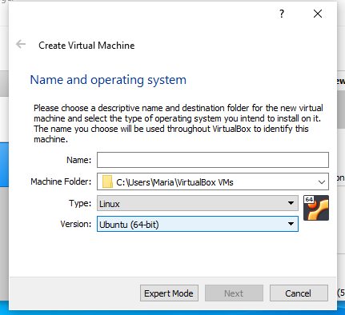

* For this exercise it must have 2GB of RAM memory

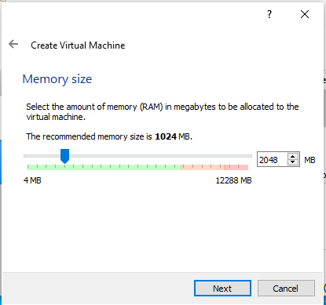

* I have chosen a 30.00GB disk because is what the statement said

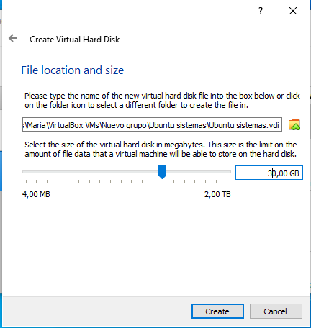

* We chose the correct language in this case English but we need to put the keyboard in Spanish and then start with the Ubuntu installation

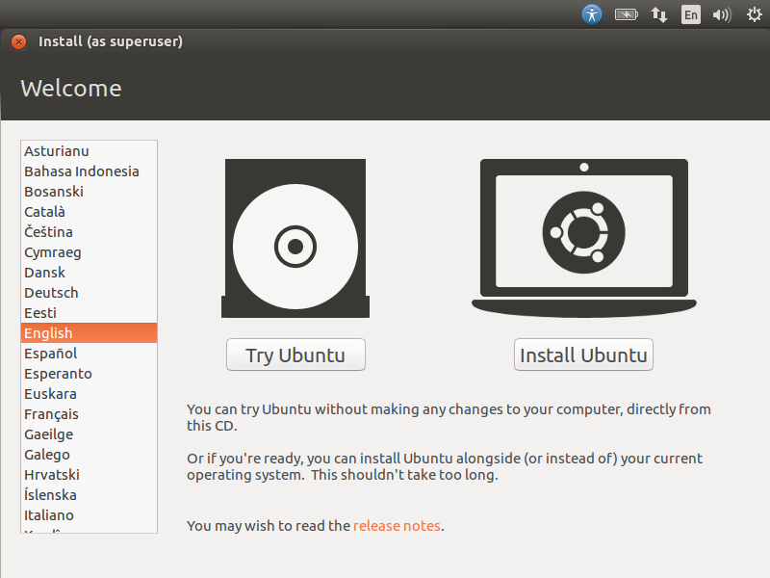

* Click on Download upadates while installing Ubuntu

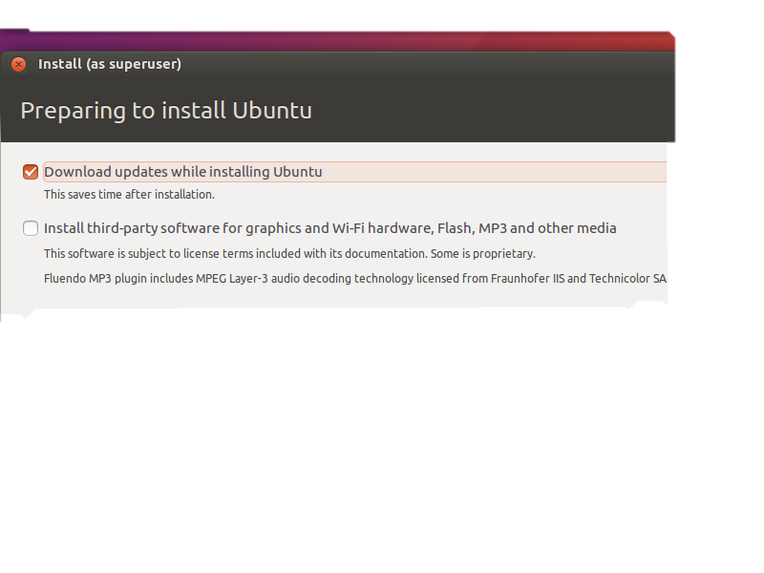

* For making the necessary partitions we chose Something else

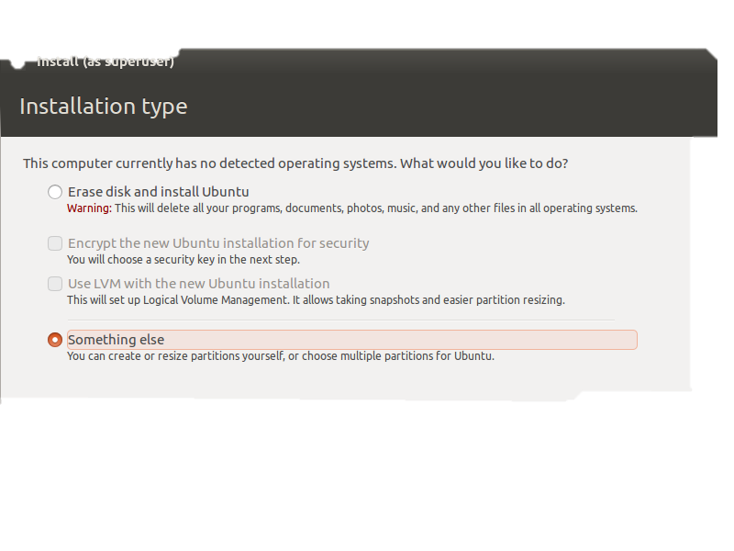

* The first partition /boot

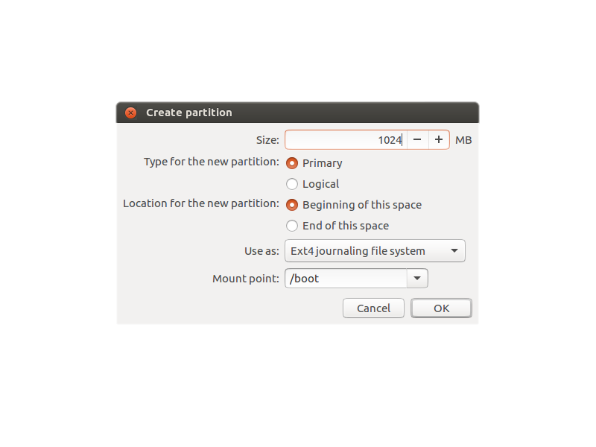

* The second logical partition, swap area

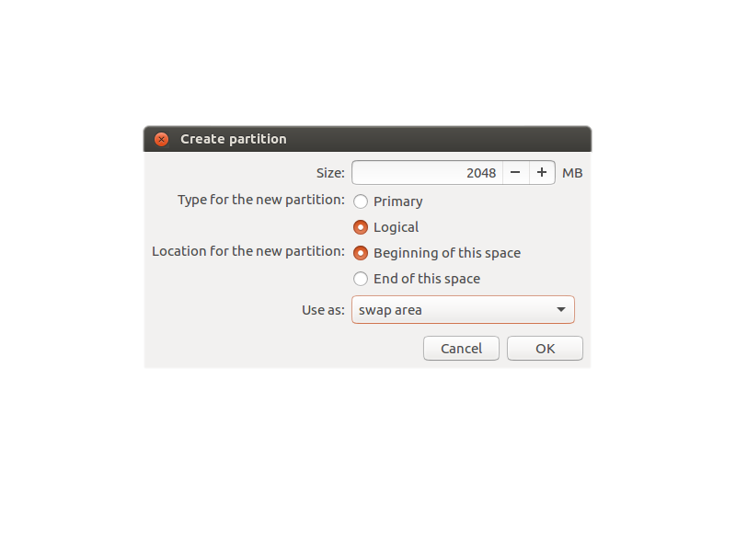

* Third, logical partition /

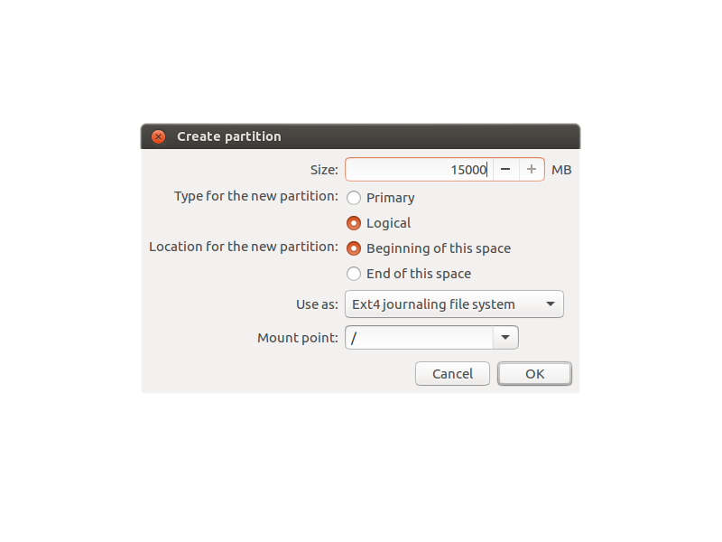

* Fourth, logical partition /home

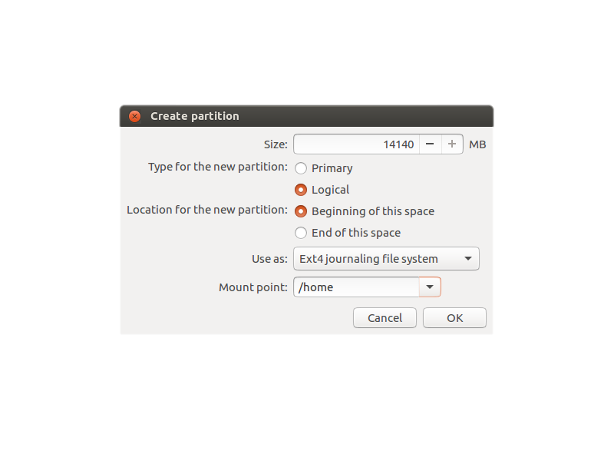

* Chose your location

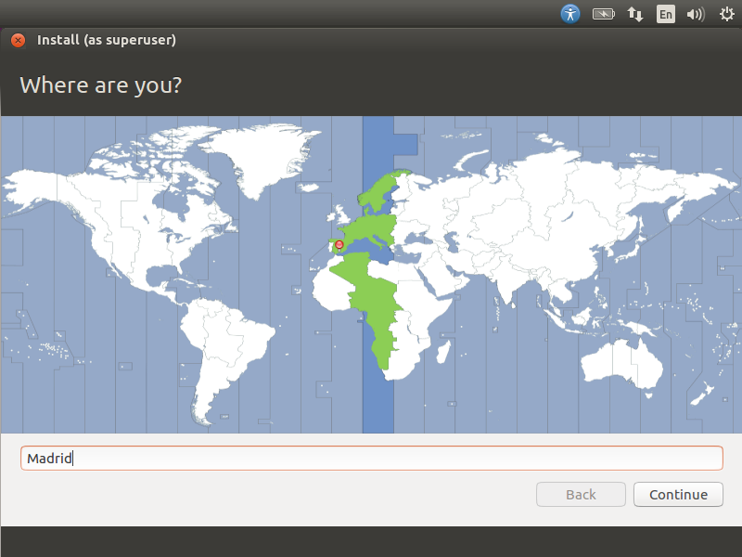

* Write the username and the password

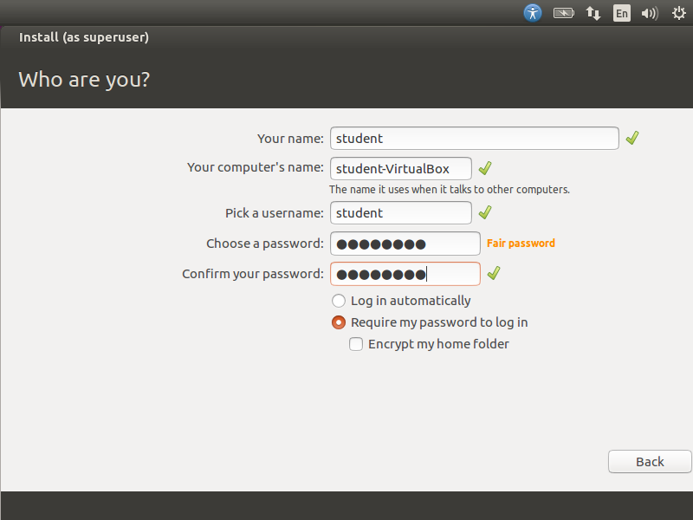

* Start the installation

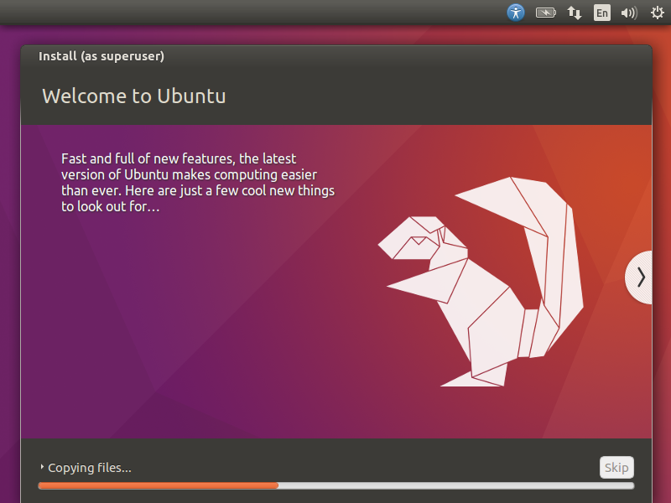

* Insert Guest Additions

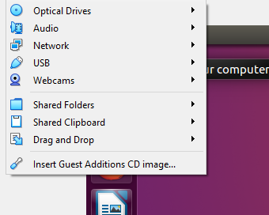

* Change the settings and put it bidirectional

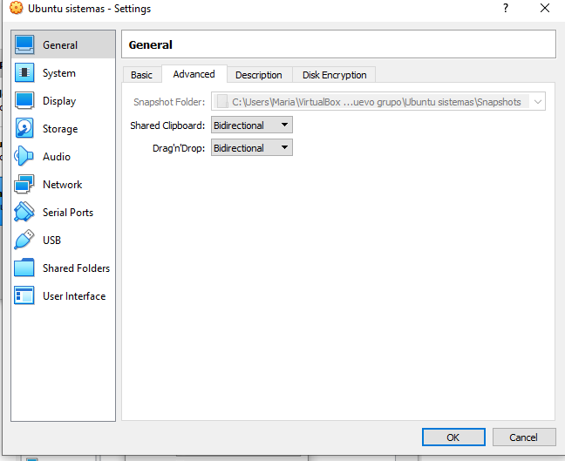

* You put the folder you want to share, in this case I chose a Folder and not a USB, and finally you chose the Auto-mount option

